Amy West
22 April 2016
Topic: Student with autism/low-incidence disability needing instruction through video modeling and visual schedule.
Enduring Understandings:
- Video models can help us remember how to do everyday skills.
- Visual schedules can help us remember how to do everyday skills.
Essential Questions: (What question(s) will students grapple with as they learn through this lesson?)
- When would video models or visual schedules be good to use in the classroom or outside of school?

Primary Content Objectives:
Students will know: (facts/information)
- The student will know that a video model is a resource to remember how to do important skills, like greeting others.
- The student will know that a visual schedule for skills, like greeting others, can be used when a video model is unavailable.
- The student will know that video models and visual schedules use steps to do a task, moving from the first step to the last step, until the task is finished.
Students will be able to do: (skills and behaviors)
- The student will make their own video model for greeting others.
- The student will be able practice greeting others using the video model and visual schedule.
Related state or national standards: (non-academic skill)

Assessment:
- Pre-assessment:
  - Record what the student did or did not know about greeting others on the task analysis chart. Note if the student needed prompting, if they knew it independently, or if they did not know the step.
    - Task analysis: Go through all of the steps and cues to greet others. The steps should be:
      - 1. Greet
      - 2. Wait and Listen
      - 3. Reply
      - 4. Take turns
- Formative: Video and schedule following: The student will follow the visual schedule and video, identifying each step as it appears, as measured on the task analysis chart.
  - Walk through how one would use the video model and the visual schedule to perform the skill. “First, we watch the video model (point to the video). We can follow the model through the video using the visual schedule”
  - (*Record data on the task analysis chart. Note if the student needed prompting, if they knew it independently, or if they did not know the step). Point to the visual schedule and watch the video while following the schedule, pointing to each step as the model does it). “Then we practice the skill using the visual schedule or rewatching the video, if we need to.”
  - Do an example of the skill, using the visual schedule, then try practicing without it. “Eventually we practice enough to do it without any help!”
- Summative:
  - The student will work with the teacher or an adult aide to make their own video model, and practice using the visual schedule for greeting others. (The model and the schedule will only be made and assessed if the student completes the pre- and formative assessments above).
  - The student will be assessed with a task analysis chart while practicing the skill of greeting others, noting if the student uses their visual schedule, if they need to rewatch the model, and if they need additional prompts, noting if they are verbal or physical.
Materials and Resources:
- Video Camera/recording device
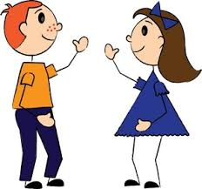
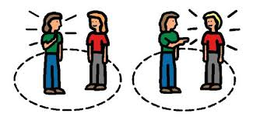
- Visual schedule sheet with picture cards for each step of greeting others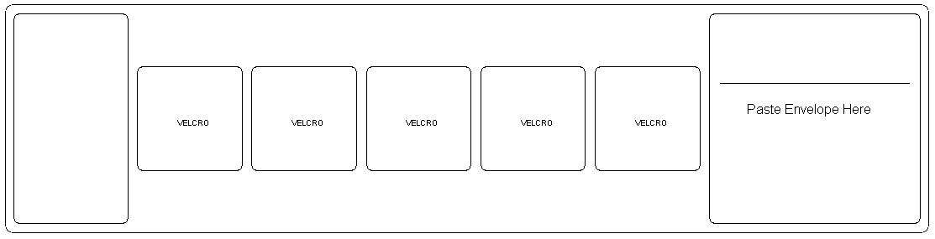
Greet
Wait and listen
Take turns
Reply
- Task analysis chart (The chart should have enough space to document the pre-assessment, formative, and summative assessments, as well as some spaces for practice.)
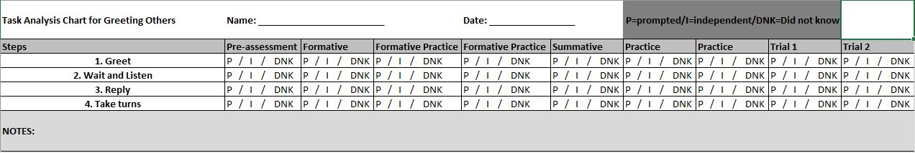
- Example video model (greeting others): https://www.youtube.com/watch?v=8l4KwA5CbqA
- Resources:
  - Wynkoop, Kaylee Stahr (20160101). "Watch This! A Guide to Implementing Video Modeling in the Classroom." Intervention in School and Clinic, 51 (3), 178-183.
  - Goodman, Gay; Williams, Cathy M. (20070701). "Interventions for Increasing the Academic Engagement of Students with Autism Spectrum Disorders in Inclusive Classrooms." TEACHING Exceptional Children, 39 (6), 53-61.

Key Vocabulary and Definitions:
- Video Model: A video model is a tape of you or someone else modeling a task. Modeling means we can watch and then imitate, or do the same thing. Video models are a resource that can help us remember how to do everyday skills, like greeting others.
- Visual Schedule: A visual schedule can be used for remembering skills step-by-step, like greeting others. We can use a visual schedule when a video model is unavailable.

Lesson Procedures:
- Introduction and goal orientation:
  - Explain to the student, “The goal for today is for us to make our own video model and practice using a visual schedule to help us work on a new skill. The skill we will practice today is greeting others.” (If the student seems discouraged, encourage them by explaining how important it is to know how to greet others. For example, greeting others is important to making friends and making your friends feel good. It is important to know how to greet others so that we can start conversations with our friends and even meet new people).
  - Pre-assessment: Record what the student did or did not know about greeting others on the task analysis chart. Note if the student needed prompting, if they knew it independently, or if they did not know the step.
    - Task analysis: Tell the student there are four basic steps to greeting others. Go through all of the steps, seeing if the student can predict the next step. Guide the student and record what they already know. If this skill is already learned and mastered, consider a different skill for the rest of the lesson. Model each of the steps individually as you go. Clarifying any questions that the student might have. The steps should be:
      - 1. Greet
      - 2. Wait and Listen
      - 3. Reply
      - 4. Take turns
- Connecting to prior knowledge and experiences:
- (Re)-explain to the student what a video model is, “A video model is a tape of you or someone else modeling a task. Modeling means we can watch and then imitate, or do the same thing. Video models are a resource that can help us remember how to do everyday skills, like greeting others. What’s a video model?” Try to guide the student through the definition if they cannot repeat it right away.
- Review the example video model through the first :44 seconds: https://www.youtube.com/watch?v=8l4KwA5CbqA
- Then show the student the visual schedule to match the video model. (Re)-explain what a visual schedule is, “A visual schedule can be used for remembering skills step-by-step, like greeting others. We can use a visual schedule when a video model is unavailable. What’s a visual schedule?” Try to guide the student through the definition if they cannot repeat it right away.
- Formative assessment:
  - Walk through how one would use the video model and the visual schedule to perform the skill. “First, we watch the video model (point to the video). We can follow the model through the video using the visual schedule”
  - (*Record data on the task analysis chart. Note if the student needed prompting, if they knew it independently, or if they did not know the step). Point to the visual schedule and watch the video while following the schedule, pointing to each step as the model does it.
  - “Then we practice the skill using the visual schedule or rewatching the video, if we need to.” Do an example of the skill, using the visual schedule, then try practicing without it. Provide positive feedback to the student for any effort and encourage them to look back at the visual schedule. This practice is not for data but is for practice using the visual schedule.“Eventually we practice enough to do it without any help!”
- Ask the student, “When would video models or visual schedules be good to use in the classroom or outside of school?” Have the student try to list a few examples. Prompt them as needed.
- Practice video: Have the student make a video with themselves to see if they are comfortable. Possibly give the child a short script with verbal or physical “lines” to practice being videoed. This can also give the teacher a chance to practice using the video recording device.
- Tasks and activities:
- Summative assessment: Make the video following the video schedule. Record one step at a time. If the student struggles with the sub-steps, consider multiple visual schedule cards for each step. If the student messes up or wants to try again, let them, and encourage them.
  - Begin with “Greet.” Have the student walk up to you and greet you with something like, “Hello, Miss West! How are you today?” The sub-steps for greet would be: make eye contact, wave or handshake or fistbump or high-five (whatever the student prefers or handshake if they are practicing to meet new people), greet by name, question (such as how are you, what’s up, what have you been up to, etc).
  - Then focus on “Wait and listen.” Have the student practice each step cumulatively, starting with the greeting and adding on the next step, and so on. For this step, the student walks up to you and greet you with something like, “Hello, Miss West! How are you today?” Then have them “wait and listen.” The sub-steps for wait and listen would be: a calm body, a quiet mouth, listening, and eye contact.
  - Next, focus on “Reply.” Have the student greet, wait and listen, and then reply. This step may take practice. Ideally, the friend/person the student is greeting would ask the same or a similar question to what they asked. For this lesson, keep this step basic, then when practicing, the student could do a separate social story or other type of practice for conversations. The sub-steps for reply would be: think about the question, think about your answer, reply with your answer.
  - Finally, focus on “Take turns.” Have the student greet, wait and listen, reply, and then take turns in the conversation. This step, similarly to “reply” could require extra practice, possibly in different forms. Carrying a conversation and taking turns can be tough for some students. The sub-steps for taking turns in this lesson would be: ask a new question or compliment or comment, wait for your turn and listen, reply.
  - Later, if the student needs more guiding through the video, you can add the words and pictures from the video schedule to the video when the step is being performed. You can also add narration by the student or an adult.
- Summative assessment and practice: (*Record data on the task analysis chart. Note if the student needed prompting, if they knew it independently, or if they did not know the step).
  - Watch the video (repeat as necessary) while following the visual schedule: Everything up to this point has been guided. Help the student follow the video with the schedule (WE DO). See if they can then follow the schedule on their own by pointing to the steps as they appear in the video (YOU DO). Record on the task analysis chart. Repeat at least two more times to ensure accuracy. If the student is struggling, guide and prompt again, fading and testing as the child can handle it.

- Closure:
- To close the lesson, the student can try to perform the skill of greeting others on their own using the visual schedule and after watching the video model. Continue to collect data, recording which steps were performed correctly without prompting or additional cues. Eventually, both the video model and the visual schedule would be faded until mastery of the skill was completed. (*Record data on the task analysis chart. Note if the student needed prompting, if they knew it independently, or if they did not know the step).
- It could be a fun closing activity for the student to share their video with a peer that could also benefit from the video or would benefit from learning about video modeling or visual schedules in general.
Accommodations for individual differences:
- Model choice (some students may be uncomfortable with either being filmed or watching themselves in a video, so it is important that the student is comfortable with the model, whether it be themselves, a peer, or an adult).
- All of this lesson could be extended across multiple days/lessons as the child needs or can handle.
- Some students may benefit from adding music to the video and activity to help them stay calm while remembering all the steps.
- The student would benefit from guided steps that fade and positive feedback/reinforcement upon giving good effort. An extra reinforce could be given if the objective is reached.
Behavioral and organizational strategies:
- All material should be modeled, guided, scaffolded, and faded at a speed that the student is most comfortable with and can learn best with.
Rationale:
- This is a multi-step skill that could take a lot of scaffolding for students with more severe disabilities, however with explicit and systematic instruction, many students can learn it (or at least get better with it) with the help of video models, visual schedules, and practicing.

