Ancient Mali One Week Unit for Third Grade:
“From Here to Timbuktu”
Amy M. West and Corrie L. Shellnutt
University of Virginia, EDIS 5340, Spring 2016

Table of Contents
- Title Page
- Table of Contents
- Unit Goal and Rationale
- Unit Standards (Two pages)
- Class Profile
  - Class Profile Description and Rationale
- Parent Letter
- Unit Plan Outline (Two pages)
- Unit Assessment
- Day 1 Lesson Plan
  - Docs
- Day 2 Lesson Plan
  - Docs
- Day 5 Lesson Plan
  - Docs
- Resources
Unit Goal and Rationale
Goal and Rationale
Students will experience Malian culture in a meaningful way by researching and creating the photostory foldable. In doing so, the goal is for students to develop their own ideas and motivations, allowing for an authentic understanding of multiple persepectives. Integrating technology during the process of creating the foldable allows students to successfully organize and create a finished project beginning with a rough draft. Students will produce reflective and peer feedback after the gallery walk to promote a classroom community of learners.

How are your lesson topics connected, i.e. what critical thinking ‘links’ ideas together?
By following the Experiemental Exercise Model described in TCI, students participate in daily activities that lead to the final photostory foldable centered around Ancient Malian history. Each day students will consider the ways studying multiple perspectives helps in understanding big ideas surrounding how societies develop and evolve.
What is your end-of-unit assessment?
The end-of-unit assessment we are using for this unit is a photo story foldable in which students will plan and work in groups and as individuals. Students will research using supplied resources, fill out a graphic organizer, and write 3-4 sentences for each section of the graphic organizer, accompanied by a drawing, symbol or picture. Students will exhibit their foldable in a gallery walk on the last day and give short reflective and peer feedback on their work. Students will also do a set of practice SOL questions on Mali.
Unit Standards

VA SOL
- Social Studies (2015)
Skills
3.1 The student will demonstrate skills for historical thinking, geographical analysis, economic decision making, and responsible citizenship by
b) using geographic information to support an understanding of world cultures;
c) interpreting charts, graphs, and pictures to determine characteristics of people, places, or events in world cultures;
d) summarizing points and evidence to answer a question;
e) comparing and contrasting ideas and perspectives to better understand people or events in world cultures;
i) practicing good citizenship skills and respect for rules and laws while collaborating, compromising, and participating in classroom activities; and
j) accessing a variety of media, including online resources.
History
3.4 The student will describe the oral tradition (storytelling), government (kings), and economic development (trade) of the early West African empire of Mali.
Geography
3.6 The student will develop map skills by using globes and maps to locate and describe major rivers, mountain ranges, and other geographic features of
a) Africa
Economics
3.9 The student will recognize that because people and regions cannot produce everything they want, they specialize in what they do best and trade for the rest.
English (2010)
3.1 The student will use effective communication skills in group activities.
a) Listen attentively by making eye contact, facing the speaker, asking questions, and summarizing what is said.
b) Ask and respond to questions from teachers and other group members.
3.5 The student will read and demonstrate comprehension of fictional text and poetry.
a) Set a purpose for reading.
b) Make connections between previous experiences and reading selections.
c) Make, confirm, or revise predictions.
d) Compare and contrast settings, characters, and events.
g) Draw conclusions about text.
l) Differentiate between fiction and nonfiction.
3.9 The student will write for a variety of purposes
e) Use strategies for organization of information and elaboration according to the type of writing.
g) Revise writing for clarity of content using specific vocabulary and information.
3.12 The student will use available technology for reading and writing.
NCSS Standards
Thematic Standards:
- Culture and Cultural Diversity
- People, Places, and Environments
- Individuals, Groups, and Institutions
- Power, Authority, and Governance
- Production, Distribution, and Consumption
- Science, Technology, and Society
- Global Connections
Disciplinary Standards
- History
- Geography
- Civics and Government
- Economics
TCI Approach: Experiential Exercises
- Exercises to help students truly grasp key social studies concepts.
- Prepare your students for a safe, successful experience.
- Make the experiences as authentic as possible.
- Allow students to express their feelings immediately after the experience.
- Ask carefully sequenced questions to help students make connections between their experience and key concepts.

Class Profile
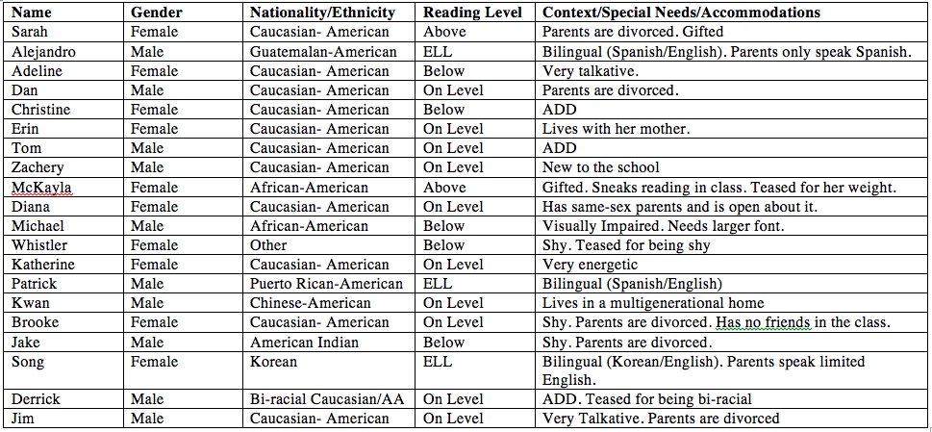

Class Profile Description and Rationale

General description

This third grade class is very unique, varying in language abilities, reading level, personalities, and various disabilities. The class consists of 11 males and 9 females, ranging in various nationalities and ethnicities. Language wise, three students are identified as ELL, two in Spanish and one in Korean. 50% of the students are on-grade level for reading, two students are gifted/above-grade level in reading, and five students are currently below grade level in reading. A few of the students have identified disabilities, including three with ADD, and one visually impaired. 35% of the students are dealing with divorced or single parents, and one student lives in a multi-generational home. The class gets along well, aside from a few talkative and shy students, and some teasing that we are working on together to address.

Rationale

This profile was edited from the original to lower the class size and eliminate some of the differing languages and disabilities. We thought this class may be on the extreme side in variability, however, it is likely that we could receive a class one day needing this level of differentiation. We also decided to keep most of the students because Corrie is getting her endorsement in ELL and Amy is getting hers in special education.

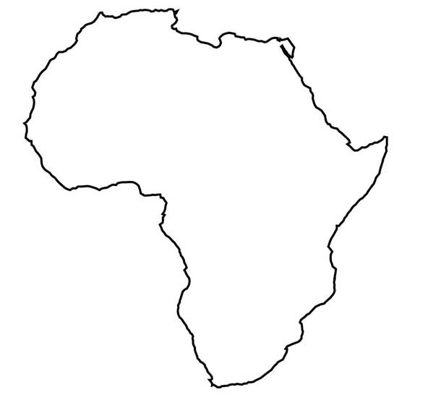
Hello Families!

Ever heard the phrase “from here to Timbuktu?” After this week our class will be able to locate and discuss the culture and geography of Ancient Mali.

The Empire of Mali was the largest and wealthiest in West Africa with a profound influence in the region through the spread of its language, goods, and customs along the Niger River, leading to the capital, Timbuktu. Remembered for the wealth of their powerful ruler, Mansa Musa, the empire flourished by harvesting and trading valuable resources like salt and gold.

Our main goal for this Unit is to understand the culture of Ancient Mali by researching and creating photostory foldables, a descriptive project created using text and images pasted into a manila folder (image below). In addition to making photostory foldables, we will study maps, learn African dances, and read stories.

Thank you!

Ms. West and Ms. Leigh
Amw7jd@virginia.edu
Cls4ct@virginia.edu

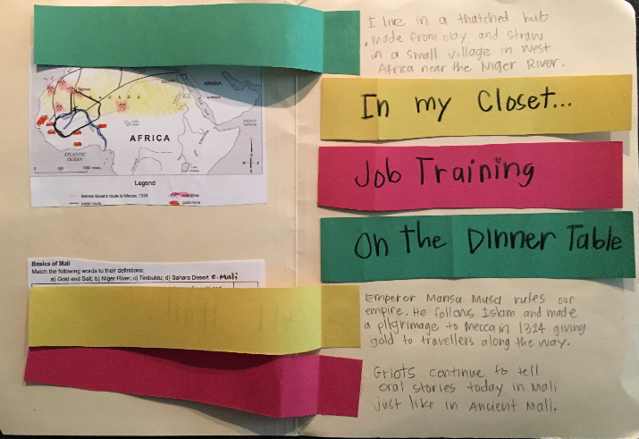
Unit Plan Outline
Day 1: Hook ‘Em | Day 2: Lesson 1 | Day 3: Lesson 2 | Day 4: Lesson 3 | Day 5: Assessment
NCSS:  Global Connections, People, Places, and Environment, Geography, and History  SOL:  3.1 b,c,d,i, and j  3.4  3.6 a  3.9  Warm Up: (15 min)  (What do you know about Africa?)  -Google Earth (explore and connect to Lion King)  Activity: (25 min)  -Students will be given a world map and map of Mali to label the Sahara Desert, the Niger River, and Timbuktu.  -(Begin whole group, “I do” and “We do”) Prezi with resources for graphic organizer (Prezi should be set up to look like GO so resources are easier to use; peer buddies/accepting written or drawn answers to finish)  Debrief: (10 minutes)  -Story: I Lost My Tooth in Africa by Penda Diakite & Baba Wague Diakite (Read to a point then make predictions, finish story next lesson)  -Explain the homework | NCSS:  Geography, History, Economics, Culture and Cultural Diversity,  People, Places, and Environments, Individuals, Groups, and Institutions, Productions, Distribution, and Consumption  SOL:  3.1 b,c,d,i, and j  3.4  3.6 a  3.9  TCI EE Step 2 and 3  Warm Up:  -Finish the story from Day 1  -Review Basics of Mali GO and Map  Activity:  -Introduce Personalities for Project (storytellers, miners, salt people, kings, traders, farmer, tour guide)  -Pick personalities and split into groups (random order)  -Plan and work in groups to start filling out GO for individual photo story foldables  Debrief:  -Show a finished example of a photo story foldable.Questions.  -Start learning Clock dance  -Exit ticket: Write in your “Learning Log” one idea that you have for your photo story. | NCSS:History, Economics, Culture and Cultural Diversity,  People, Places, and Environments, Individuals, Groups, and Institutions, Productions, Distribution, and Consumption  SOL:  3.1 b,c,d,i, and j  3.4  3.9  TCI EE Step 2 and 3  Warm Up:  -Mali Video to focus in on personalities  Activity:  -Finish GO on personalities  -Start making photo story foldable text rough drafts of 3-4 sentences for each GO section.  Debrief:  -Clock dance  -Exit Ticket: Write in your “Learning Log” a list of things that you have left to finish for your photo story foldable to prepare for tomorrow’s lesson. | NCSS:History, Economics, Culture and Cultural Diversity,  People, Places, and Environments, Individuals, Groups, and Institutions, Productions, Distribution, and Consumption  SOL:  3.1 b,c,d,i, and j  3.4  3.9  TCI EE Step 2 and 3  Warm Up:  -Millionaire SOL practice  Activity:  -Continue working on photo stories  -Regroup and work together on photo story foldables  -Teacher conference by group to polish before gallery walk  Debrief:  -Clock dance  -Share photo story foldables with group | NCSS:History, Economics, Culture and Cultural Diversity,  People, Places, and Environments, Individuals, Groups, and Institutions, Productions, Distribution, and Consumption  SOL:  3.1 b,c,d, e, ,i, and j  3.4  3.9  TCI EE Step 4 and 5  Review:  -Gallery walkthrough  Assessment:  -Personality Packets  -Reflective and Peer feedback short forms  -SOL Practice Questions:  http://www.proprofs.com/quiz-school/quizshow.php?title=mali-3rd-grade-test&q=1  Potential Debrief:  -Read a book and finish reflection
Pre-Assessment:  -Observation during activities, noting insights and interests about Mali  -Graphic Organizer on Basics of Mali  -Map Labeling |  |  | Formative Assessment:  -Teacher Conference  -Observation of group sharing | End-of-Unit Assessment:  -Finished Photo Story Foldable  -SOL practice questions
Homework?  -Finish GO and Map  -Write predictions and one thing you’re curious about Mali in your “Learning Log” | Homework?  -None | Homework?  -Work on foldable  -Share foldable with someone | Homework?  -Finish foldable if not finished  -Practice on SOL practice test online | Homework?  -None

Unit Assessment
Pre-Assessment:
    - -Observation with checklist during activities, noting students current insights and interests about Mali
    - -Graphic Organizer on Basics of Mali
    - -Map Labeling
Formative Assessment:
    - -Teacher Conference with checklist
    - -Observation of group sharing with checklist for each group
End-of-Unit Assessment:
    - -Finished Photo Story Foldable, measured by rubric
    - -SOL practice questions

Amy West and Corrie Shellnutt
Grade 3
Lesson Day 1
Ancient Civilizations: Mali

Enduring Understandings:
- Ancient civilizations relate to modern life.
- Physical geography impacts culture and economy.

Essential Questions:
- How can physical geography and climate impact the growth of a civilization?

Primary Content Objectives:
Students will know:
- Mali is a country in Africa with rich culture that developed from a powerful ancient civilization.
- The Niger River helped support the development of trade and industry in Mali.

Students will be able to do: (skills and behaviors)
- Locate Mali on a world map
- Describe the landscape and climate of Mali
- Locate the city of Timbuktu and the Sahara Desert
- Indicate the route of the Niger River and discuss the river's economic significance

Related state or national standards:
VA SOL Standards
  - Skills
    - 3.1 The student will demonstrate skills for historical thinking, geographical analysis, economic decision making, and responsible citizenship by
b) using geographic information to support an understanding of world cultures;
c) interpreting charts, graphs, and pictures to determine characteristics of people, places, or events in world cultures;
d) summarizing points and evidence to answer a question;
i) practicing good citizenship skills and respect for rules and laws while collaborating, compromising, and participating in classroom activities; and
j) accessing a variety of media, including online resources.
  - History
    - 3.4 The student will describe the oral tradition (storytelling), government (kings), and economic development (trade) of the early West African empire of Mali.
  - Geography
    - 3.6 The student will develop map skills by using globes and maps to locate and describe major rivers, mountain ranges, and other geographic features of a) Africa
  - Economics
    - 3.9 The student will recognize that because people and regions cannot produce everything they want, they specialize in what they do best and trade for the rest.
- NCSS Standards
  - Thematic Standards:
    - Culture and Cultural Diversity
    - People, Places, and Environments
    - Global Connections
  - Disciplinary Standards
    - History
    - Geography
Assessment:
- Diagnostic:
  - Students will be observed during the virtual tour warm up noting students current insights and interests about Mali.
- Formative:
  - Discussions and output produced during the map labelling exercise.
  - Predictions from I Lost My Tooth In Africa,
- Summative:
  - Students will complete the world map and map of Mali
  - Students will complete the “Day in the Life” Graphic Organizer

Materials and Resources: (List here all materials that you will need in order to successfully teach this lesson. Include technology and website links, texts, graphic organizers, student handouts, physical manipulatives, etc.)
- “Day in the Life” Graphic Organizer
- World maps
- Topographic and political maps of Mali
- Projector/SmartBoard
- I Lost My Tooth in Africa by Penda Diakite and Baba Wague
- Google Earth Tour of Mali (for reference to location and climate)

Key Vocabulary and Definitions:
- Mali- a country located in West Africa with desert-like climate known for gold and salt mining, oral tradition,and trade
- Niger River- a river spanning 2,600 miles through Mali integral in establishing trade within the region
- Timbuktu- an important city located along the Niger in Mali featuring a university library with a number of Greek and Roman texts.
- Sahara Desert- the largest desert in the world, located partially in Mali bordering Timbuktu
- Gold and Salt- minerals mined in Mali

Lesson Procedures:

1. Introduction and goal orientation: (5 min)
- The teacher should begin the lesson by displaying the essential understandings and questions and objectives, allowing students to become oriented for the lesson.
- Next, the teacher should go over class and lesson expectations. A short 5-minute or less review of the classroom expectations will suffice for this lesson.

2. Connecting to prior knowledge and experiences: (10 min)

- Ask students, “What do you know about Africa?”
- Using Google Earth explore West Africa, focusing on the city Timbuktu and the Niger River as well as Mali’s position on the globe (eastern and western hemisphere near the equator). Encourage students to consider the climate and physical landforms during these observations. The teacher should have a Google Earth Tour prepared before the lesson.

3. Tasks and activities: (25 min)

- Begin the tasks and activities by giving students a world map. Students will label Mali on the map, noting the closest/surrounding countries, continents, oceans, and hemispheres.
- Then provide studnets with a map of Mali (or have the map on the flip side of the world map) to label the Sahara Desert, the Niger River, and Timbuktu. Have students think-pair-share to discuss the importance of the Niger River, the Desert, and Timbuktu, in accordance with the definitions:
  - Niger River- a river spanning 2,600 miles through Mali integral in establishing trade within the region
  - Timbuktu- an important city located along the Niger in Mali featuring a university library with a number of Greek and Roman texts.
  - Sahara Desert- the largest desert in the world, located partially in Mali bordering Timbuktu
- For the next portion, begin whole group to explain the graphic organizer and how to navigate the Prezi and use the resources to fill out the graphic organizer.
- Break up students into peer buddies, mixing abilities. This “we do” portion will help students of lower abilities become more oriented with the Prezi, resources and GO before working independently. (Prezi should be set up to look like GO so resources are easier to use; peer buddies/accepting written or drawn answers to finish)

4. Closure: (10 min)

- Introduce I Lost My Tooth in Africa by Penda Diakite & Baba Wague Diakite.
- Explain, “We are about to read a story about a little girl named Amina who loses her tooth while visiting her family in Mali.”
- Stop half way through the text and ask students to make predictions about the ending of the story. “What happens after Amina puts her tooth under the gourd?”
- Homework?
  - Finish GO
  - Write predictions about I Lost My Tooth in Africa, and one thing you’re curious about Mali in your “Learning Log”

Accommodations for individual differences:
- Prezi modeled in the same format as the GO
- Visual aids- maps, virtual tour of Mali
- Peer Buddies of mixed abilities (pairing for ELL/below level readers and students with identified disabilities)
- Explicit and systematic instruction: “I do,” “we do,” “you do”

Behavioral and organizational strategies:
- Peer buddies
- Scaffolded instruction
- Classroom expectations
- Outlining the objectives of the lesson in the introduction
- For attention when announcing, adjusting directions or before transitioning: “One, two, three, eyes on me.” “One, two, eyes on you.”

Rationale:
This lesson “hooks” students in for the Unit on the Mali through engaging warm up of prior knowledge and interactive activities. By focusing on geography during this lesson, students can contextualize the impact geography has on the Ancient Malian civilization during subsequent lessons. Students will engage with peers and as a whole class in preparation for the group and individual work with the resources for the project in the upcoming lesson plans and assessments.
Day in the Life with
Mali Personalities
Directions: Fill in the GO below to help you prepare for a Gallery Walk, sharing a Mali Personality. You will create a photo story to tell about your personality. Be sure to be accurate, as you will be tested on your knowledge on Mali after the Gallery Walk!

______________________________________________________________________________
Name of personality (storytellers, miners, salt people, king/queen, traders)
Home Sweet Home: Where does your person live? What is the inside of their home like?
In the Closet: What does your person wear, usually? Is it typical? (typical means like everyone else)
Job Training: What is your person’s job like? What are their duties? Where do they work? What is their pay like?
On the Dinner Table: What does your person eat? Where does their food come from?
All Hail….: Who is in power in the government? How does this affect your person?
Fun Fact: Write here any fun facts you want to share about Mali or your person.

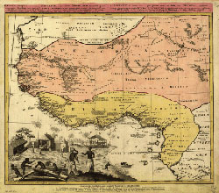

INSERT DAY 2 HERE
Amy West & Corrie Shellnutt
EDIS 5340 Grimes
Unit Lesson Day 5

Topic: Ancient Mali Gallery Walk
Enduring Understandings:
- Students will understand that there are different people within one culture.
Essential Questions:
- How can I provide good, corrective feedback for my peers?

Primary Content Objectives:
Students will know:
- Students will know the basics of Mali and information about the personalities.
Students will be able to do:
- Students will know how to work with peers and as a classroom community
- Students will know how to provide corrective feedback.
Related state or national standards:

VA SOL
- Social Studies (2015)
Skills
3.1 The student will demonstrate skills for historical thinking, geographical analysis, economic decision making, and responsible citizenship by
b) using geographic information to support an understanding of world cultures;
c) interpreting charts, graphs, and pictures to determine characteristics of people, places, or events in world cultures;
d) summarizing points and evidence to answer a question;
e) comparing and contrasting ideas and perspectives to better understand people or events in world cultures;
i) practicing good citizenship skills and respect for rules and laws while collaborating, compromising, and participating in classroom activities; and
j) accessing a variety of media, including online resources.
History
3.4 The student will describe the oral tradition (storytelling), government (kings), and economic development (trade) of the early West African empire of Mali.
Economics
3.9 The student will recognize that because people and regions cannot produce everything they want, they specialize in what they do best and trade for the rest.
TCI Experiential Exercises
- Allow students to express their feelings immediately after the experience.
- Ask carefully sequenced questions to help students make connections between their experience and key concepts.

Assessment:
- Reflective and peer feedback
- SOL Practice Questions
- Individual Personality Packets
Materials and Resources:
- Three copies of the Personality GO for each person, stapled to their own
- Projector and embedded link to dance video: https://www.youtube.com/watch?v=Ewqq-3xJFdI
- SOL questions link on tablets/computers: http://www.proprofs.com/quiz-school/quizshow.php?title=mali-3rd-grade-test&q=1
- Dress up clothes for each student to dress like their personality
- Computers/tablets for each student
- Pencils and copies of feedback/reflection forms

Lesson Procedures:
- Introduction and goal orientation:
- Goals and expectations:
  - “Today we will be finishing up our unit on Ancient Mali (). We will begin by doing our dance, dressing up like our personalities, filling out our graphic organizers and feedback in our gallery walk, then finishing with practice SOL questions. My expectations are, as always, to follow our school and classroom rules. What does it mean to be a good citizen in our classroom community?”
    - “Be respectful, be responsible, be safe self.”
  - “Great, those are our rules, but how could we follow them today, do you all think?”
    - “Give constructive feedback to our friends.(Can you explain that?) It means to give a positive and then help them get better, but don’t be mean.”
  - “Awesome! I love that you said to give a positive and then also say things that would help them get better. What else?”
    - “Be safe when doing the gallery walk and keep our hands to ourselves and be respectful when handling other people’s work.”
  - “Right! Those are great suggestions. (Name), could you give me a brief overview of what we can do to follow our rules in today’s lesson?”
    - Summary

- Connecting to prior knowledge and experiences:
- Transition to the carpet/spread out in the room, follow the dance video (skipping instruction). Do it twice if students vote that they would like to do it again.

- Tasks and activities:
- Have students dress up like their personality. Provide explicit instructions for each person so that everyone can dress up as completely as they want to, wearing at least one item.
- Have students pair up with their specific peer buddy and get their graphic organizer packets. Have students place their foldables around the classroom to prepare for gallery walk then have students pay attention with the class clap (teacher claps twice, children clap three times and stop whatever they are doing to look at the teacher and “gimme five”). Explain that students will work with their buddies to each fill out their packet so that they can take home all of the information about each personality. Remind students using choral feedback what it means to work successfully and respectfully with their peer buddies (be kind, be time-wise, inside voices). Use choral feedback to reiterate the expectations of the gallery walk. “Be safe when doing the gallery walk and keep our hands to ourselves and be respectful when handling other people’s work.”
- Place feedback forms at each project. Show students the feedback form, reiterating what constructive feedback is. Remind students that we will fill out the “reflection” section later. “Each person should fill out two total feedbacks for two different people. Use constructive feedback and legible handwriting or pictures.”
- Allow students to do the gallery walk for as long as possible, as students can finish their SOL practice questions later. Monitor students to ensure they are following expectations for the walk, peer buddies, and filling out the GOs and feedback forms. Guide students with modeling and practice on constructive feedback and guide students to filling out their GOs at needed, although peer buddies would be mixed abilities.
- Have a designated place for students to place their finished GOs so that they can take them home/keep them for later. Feel free to play African-style music during the gallery walk. This can help students remember to keep inside voices.

- Closure:
- Get students attention with the class clap, give them a few minutes (2-3), to make sure they get a chance to see all of the foldables. Do another class clap or have the timer going off get their attention and transition to have students clean up by getting their foldable, finishing up feedback, and bringing it to their seat. Have students fill out their reflection after reading the feedback to the best of their ability with a table buddy while reading a story.
- Have students glue their feedback/reflection to their folder and turn it in before moving on to the next lesson/subject/SOL practice.
- Have students get on their computers/tablets and complete the practice SOL questions. Allow students to have as much time as they need, as that is how the SOL is. http://www.proprofs.com/quiz-school/quizshow.php?title=mali-3rd-grade-test&q=1

Accommodations for individual differences:
- Students below reading level are likely to also be below on writing and would be paired with someone on level or above to work together to fill out graphic organizers, feedback, and reflections using words, pictures, and sentences. Students will have practiced using peer buddies before, but expectations will be reviewed. This accommodation would specifically help Adeline, Christine, Michael, Whistler, and Jake, and also all of the students identified as ELL (Alejandro, Patrick, and Song).
- Students with ADHD and those who are talkative will do well with all of the movement and working with peers. Students who are more shy can enjoy doing the dance and dressing up at their own comfort level. This lesson prevents students from feeling isolated.
Behavioral and organizational strategies:
- Peer buddies
- Class clap (teacher claps twice, children clap three times and stop whatever they are doing to look at the teacher and “gimme five”).
- Going over expectations explicitly
- Music during gallery walk to help students remember to keep inside voices.
Rationale:
This lesson will help students summarize everything that they have worked on all week, allowing them to share with their peers, give feedback, and reflect. Students will have all the information that they need to take home and study for a future test or SOL practice and the SOL. Students will stay engaged with the song and dress up, but they have a purpose to learn and prepare for the SOL practice at the end of the lesson.

Resources
Allen, M. C. (n.d.). 3rd Grade - Mali Millionaire Game. Retrieved April 14, 2016, from https://www.quia.com/rr/37182.html?AP_
rand=1276239910
Farnham, L. “Mali Unit Plan.” Retrived from http://bcpshelpdeskelementaryhistory.weebly.com/uploads/6/3/4/6/6346085/mali_unit_
lesson_plan.pdf
Lesson 1: Trekking to Timbuktu: The Geography of Mali (Teacher Version) | EDSITEment. (2010, November 17). Retrieved April 14,
2016, from http://edsitement.neh.gov/lesson-plan/lesson-1-trekking-timbuktu-geography-mali-teacher-version#sect-assessment
Rte66c. “Mali 3rd Grade Test.” ProProfs Quiz Maker. Retrieved from http://www.proprofs.com/quiz-school/quizshow.php?title=mali-
3rd-grade-test&q=1
Social studies alive!: Methods to transform elementary instruction. (2010). Palo Alto, CA: Teachers' Curriculum Institute.
Zike, D. (2003). Dinah Zike's reading and study skills foldables: The American journey. New York: Glencoe/McGraw Hill. Retrieved
from https://collab.itc.virginia.edu/access/content/group/6c8b49c0-1129-41e6-bfcb-346518cdd363/Lesson%20_%20Unit%20
Planning %20Tools/Social%20Studies%20_%20Literacy/Reading%20_%20Study%20Skills%20Foldables%20Book.pdf

